**NAMA : Refno Indra Kusuma**

**NIM : 20180801322**

**REVIEW UTS DATABASE ORACLE**

Hubungan antar entity, Primary key, dan Foreign key dari ke 5 tabel.

|  |
| --- |
| Product |
| Product ID (PK) |
| Product Name |
| Category |
| Buy Price |
| Sell Price |
| Product Image |
| Description |

|  |
| --- |
| Order |
| Order No (PK) |
| Customer (FK) |
| Date |
| Is Deliver |

|  |
| --- |
| Stock |
| Product Name (FK) |
| Quantity |
| Date |
| Stock By |

|  |
| --- |
| Order Details |
| Order No (PK) |
| Product Name (FK) |
| Quantity |

|  |
| --- |
| Customer |
| Cust ID (PK) |
| First Name |
| Middle Name |
| Last Name |
| Shipping Address |
| Email |
| Contact |

Menampilkan dan melihat deskripsi 5 table yang sudah dibuat sesuai perintah di papan tulis

SELECT * FROM PRODUCT_NOV

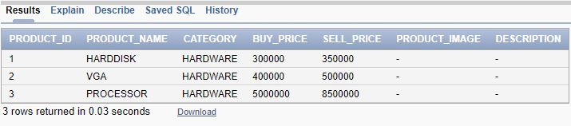

SELECT * FROM ORDER_NOV

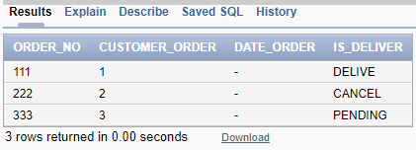

SELECT * FROM CUSTOMER_NOV

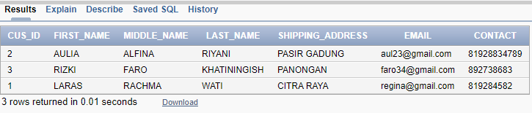

SELECT * FROM ORDER_DETAILS_NOV

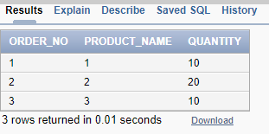

SELECT * FROM STOCK_NOV

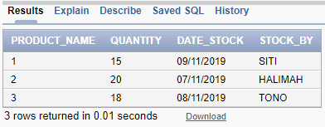

DESC PRODUCT_NOV

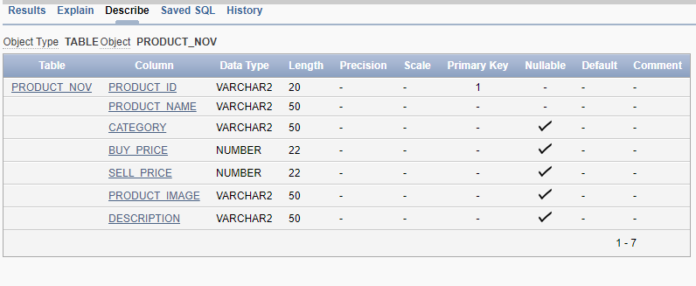

DESC ORDER_NOV

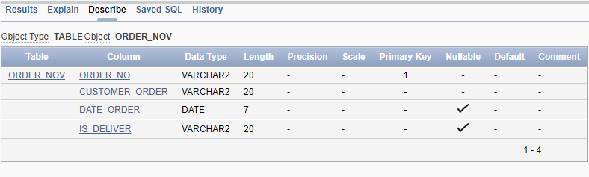

DESC CUSTOMER_NOV

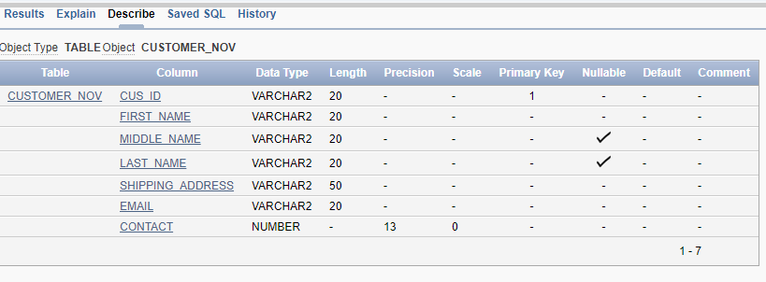

DESC ORDERDETAILS_NOV

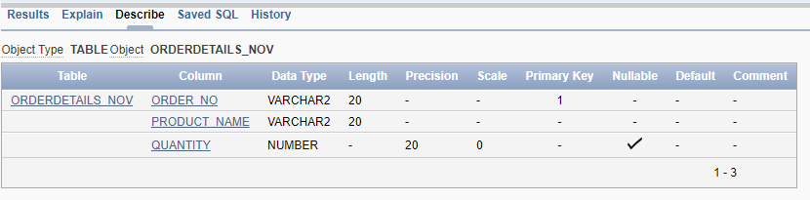

DESC STOCK_NOV

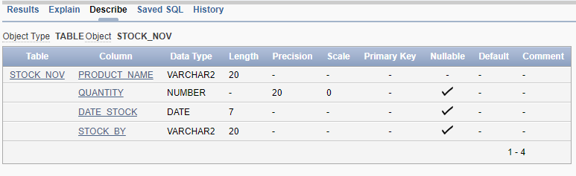

**SOAL NO 6**

**TAMPILKAN DATA TRANSAKSI**

**SELECT A.ORDER_NO, A.DATE_ORDER, C.FIRST_NAME, B.PRODUCT_NAME, B.QUANTITY, D.SELL_PRICE, B.QUANTITY*D.SELL_PRICE AS TOTAL**

**FROM ORDER_NOV A, ORDERDETAILS_NOV B, CUSTOMER_NOV C, PRODUCT_NOV D**

**WHERE B.ORDER_NO = A.ORDER_NO AND C.CUS_ID = A.CUSTOMER_ORDER AND D.PRODUCT_NAME = B.PRODUCT_NAME**

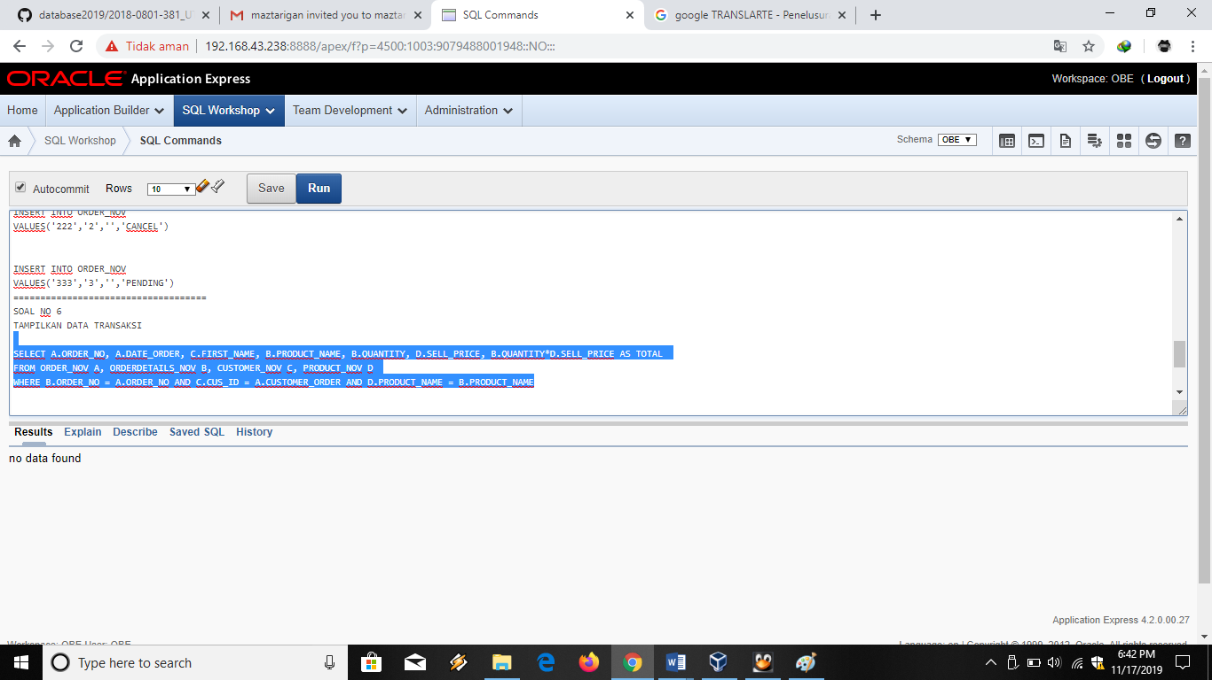

**SOAL NO 7**

**TAMPILKAN PRODUK TERBANYAK DIJUAL**

**SELECT** PRODUCT_NAME, SUM(QUANTITY)

**FROM** ORDERDETAILS_NOV

**GROUP BY** PRODUCT_NAME, QUANTITY

**ORDER BY** QUANTITY DESC

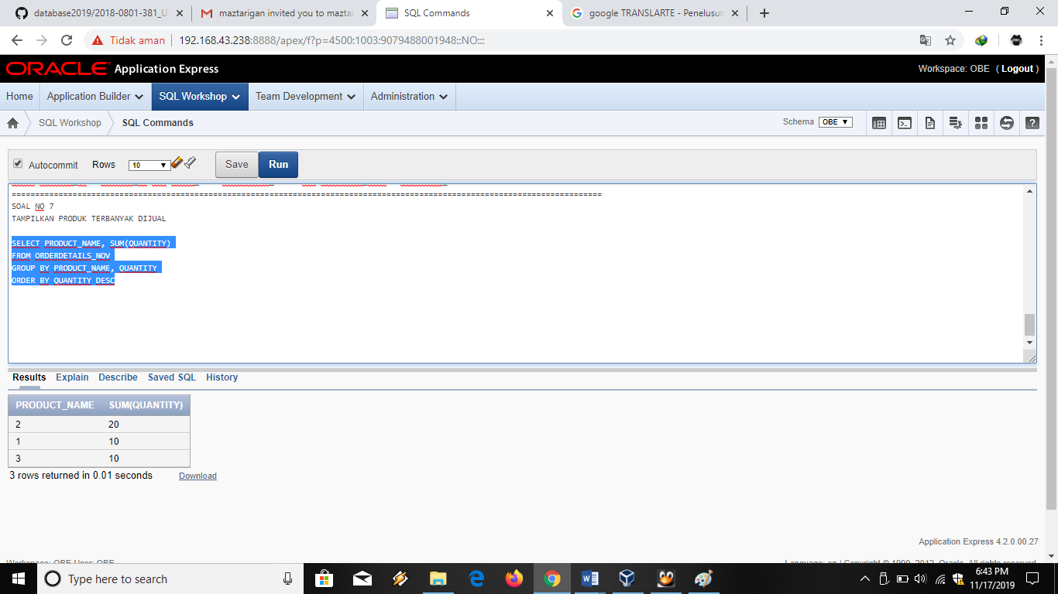

**SOAL NO 8**

**TAMPILKAN PRESENTASI PENJUALAN TIAP HARI UNTUK MASING-MASING PRODUK**

**SELECT A.DATE_ORDER, B.PRODUCT_NAME, SUM(B.QUANTITY),**

**PERSENTASE = (SUM(B.QUANTITY)/**

**SELECT SUM(D.QUANTITY)**

**FROM ORDER_NOV C, ORDERDETAILS_NOV D**

**WHERE D.ORDER_NO = C.ORDER_NO AND C.DATE_ORDER = '2019-11-16')*100**

**FROM ORDER_NOV A, ORDERDETAILS_NOV B**

**WHERE B.ORDER_NO = A.ORDER_NO AND A.DATE_ORDER = '2019-11-16'**

**GROUP BY A.DATE_ORDER, B.PRODUCT_NAME, B.QUANTITY**

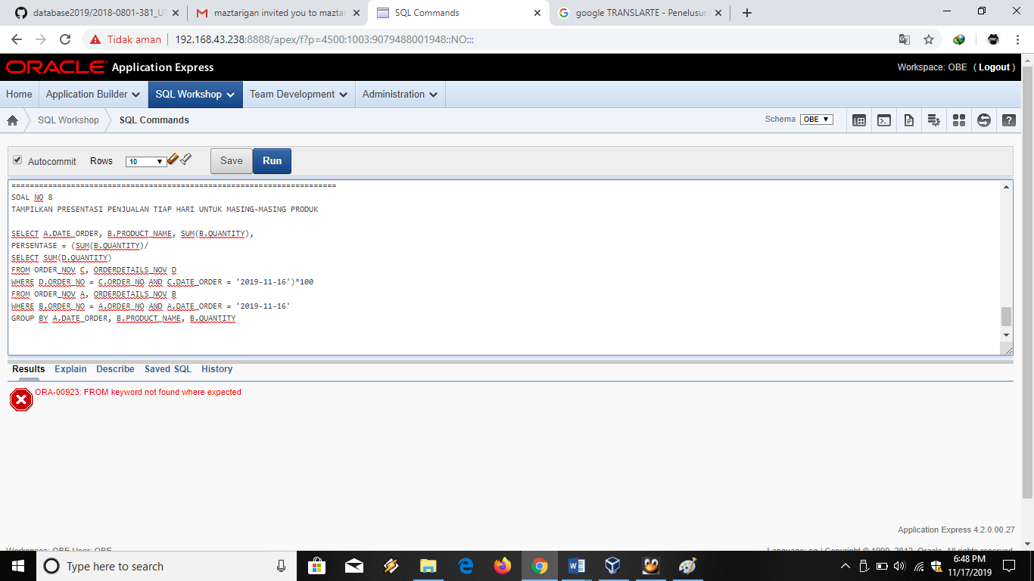

Syntax untuk menambahkan data pada **kelima** table

DESC PRODUCT_NOV

SELECT * FROM PRODUCT_NOV

INSERT INTO PRODUCT_NOV

VALUES('1','HARDDISK','HARDWARE','300000','350000','-','-')

INSERT INTO PRODUCT_NOV

VALUES('2','VGA','HARDWARE','400000','500000','-','-')

INSERT INTO PRODUCT_NOV

VALUES('3','PROCESSOR','HARDWARE','5000000','8500000','-','-')

===============================================================

DESC CUSTOMER_NOV

SELECT * FROM CUSTOMER_NOV

INSERT INTO CUSTOMER_NOV

VALUES('1','LARAS','RACHMA','WATI','CITRA RAYA','regina@gmail.com','0819284582')

INSERT INTO CUSTOMER_NOV

VALUES('2','AULIA','ALFINA','RIYANI','PASIR GADUNG','aul23@gmail.com','081928834789')

======================================================================================

DESC ORDERDETAILS_NOV

SELECT * FROM ORDERDETAILS_NOV

INSERT INTO ORDERDETAILS_NOV

VALUES('1','1','10')

INSERT INTO ORDERDETAILS_NOV

VALUES('2','2','20')

INSERT INTO ORDERDETAILS_NOV

VALUES('3','3','10')

===================================================

DESC STOCK_NOV

SELECT * FROM STOCK_NOV

INSERT INTO STOCK_NOV

VALUES('1','15','09/11/2019','SITI')

INSERT INTO STOCK_NOV

VALUES('2','20','07/11/2019','HALIMAH')

INSERT INTO STOCK_NOV

VALUES('3','18','08/11/2019','TONO')

==========================================

DESC ORDER_NOV

SELECT * FROM ORDER_NOV

INSERT INTO ORDER_NOV

VALUES('111','1','','DELIVE')

INSERT INTO ORDER_NOV

VALUES('222','2','','CANCEL')

INSERT INTO ORDER_NOV

VALUES('333','3','','PENDING')